Lock Object name must begin with ‘E’ ie EZ or EY.

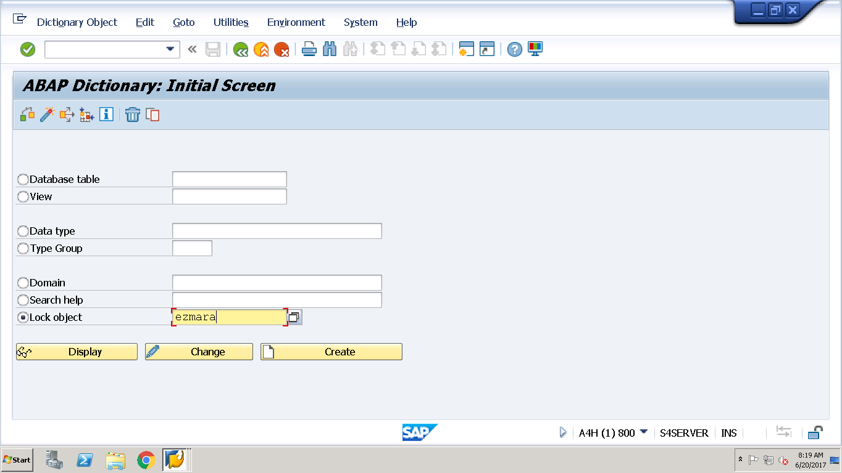

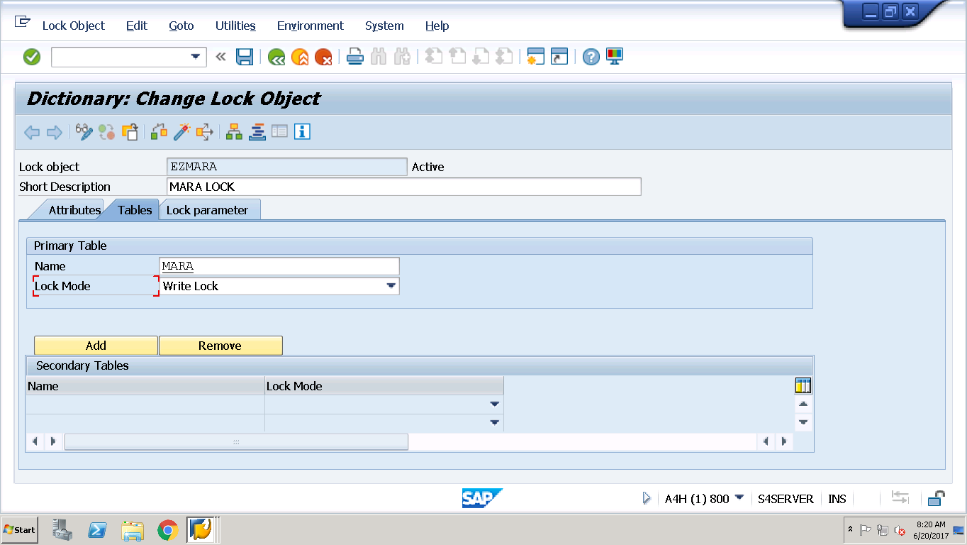

In General , Write Lock Make sense.

Lock Parameters are always on primary Key of the Table and can be verified . i.e

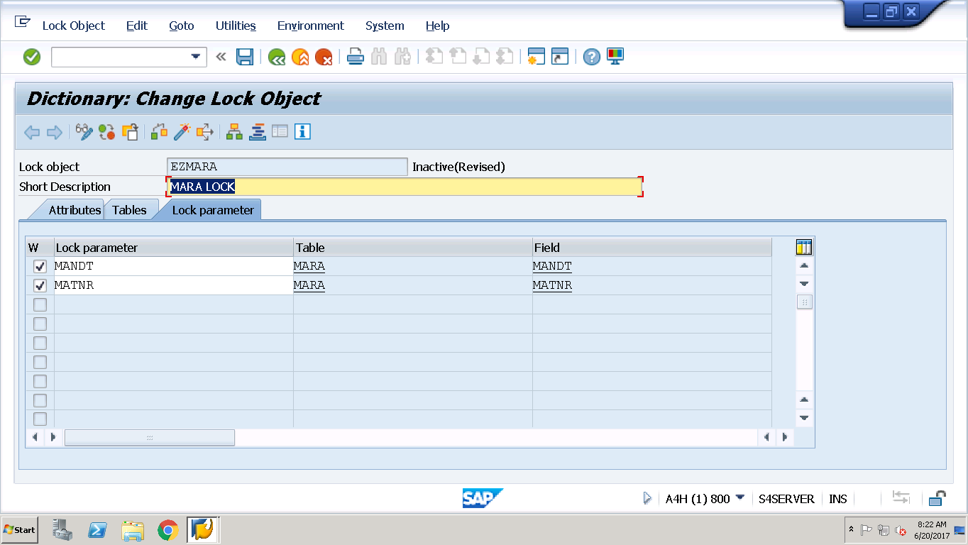

Activate it and it generated TWO Function Modules.

ENQUEUE_<LockObj Name> - > To Lock

Database updation Logic

DEQUEUE_<LockObj Name> -> To Release Lock

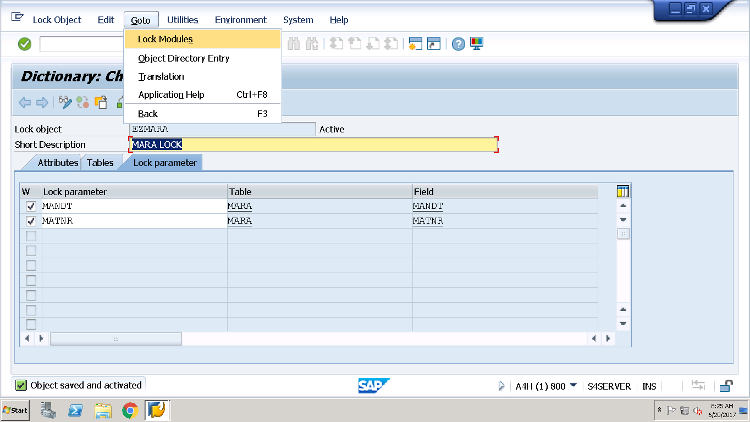

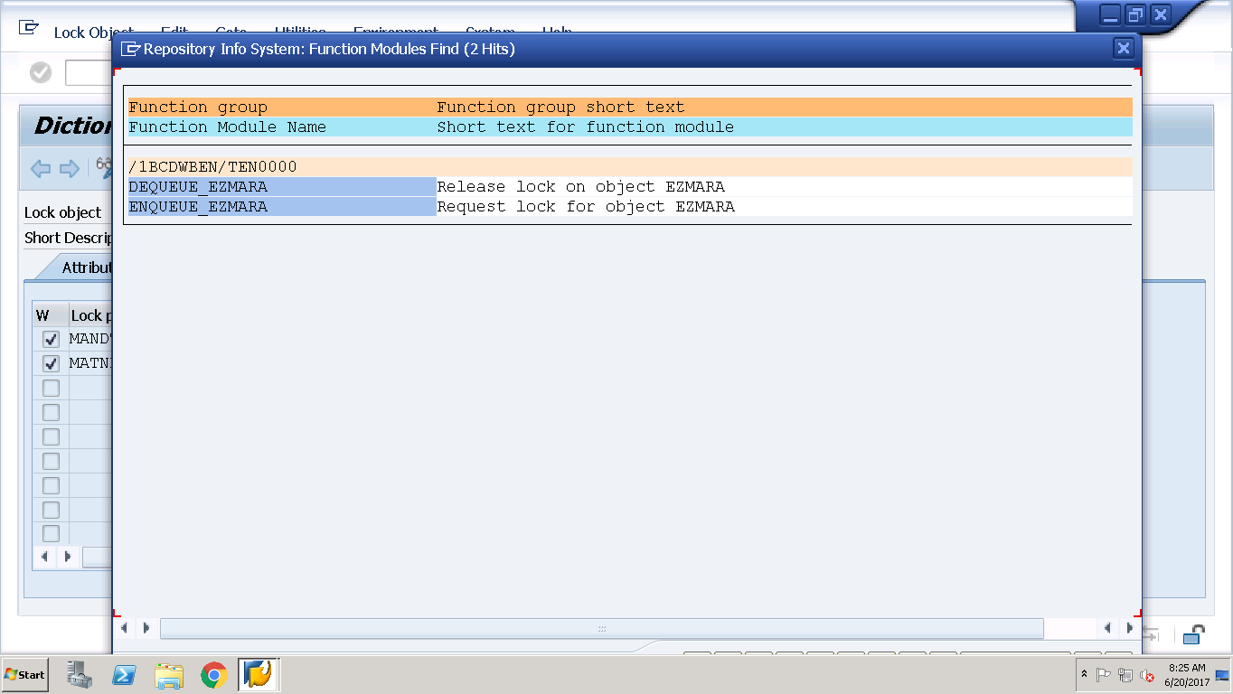

Program to Test the Same.

*&---------------------------------------------------------------------*  
*& Report ZAPPLY_LOCK_OBJECTS  
*&---------------------------------------------------------------------*  
*&  
*&---------------------------------------------------------------------*  
REPORT ZAPPLY_LOCK_OBJECTS.  
  
PARAMETERS p_matnr type matnr.  
  
CALL FUNCTION 'ENQUEUE_EZMARA'  
 EXPORTING  
*   MODE_MARA            = 'E'  
*   MANDT                = SY-MANDT  
   MATNR                =  p_matnr  
*   X_MATNR              = ' '  
*   _SCOPE               = '2'  
*   _WAIT                = ' '  
*   _COLLECT             = ' '  
* EXCEPTIONS  
*   FOREIGN_LOCK         = 1  
*   SYSTEM_FAILURE       = 2  
*   OTHERS               = 3  
          .  
IF SY-SUBRC <> 0.  
* Implement suitable error handling here  
ENDIF.  
  
UPDATE mara set matkl = '0001' where matnr = p_matnr.  
  
CALL FUNCTION 'DEQUEUE_EZMARA'  
* EXPORTING  
*   MODE_MARA       = 'E'  
*   MANDT           = SY-MANDT  
*   MATNR           =  
*   X_MATNR         = ' '  
*   _SCOPE          = '3'  
*   _SYNCHRON       = ' '  
*   _COLLECT        = ' '  
          .

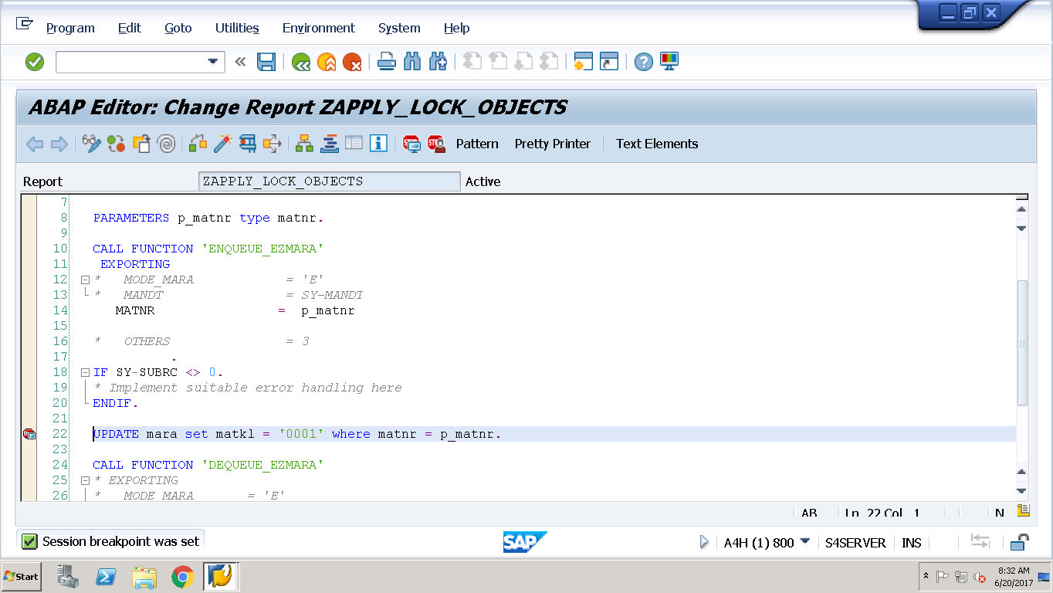

Execute the above using f8. Select Mat number and press enter. Notice the Break point is after Locking but before releasing the lock and meanwhile if the same material is tried to be changed by any, we should get the message.

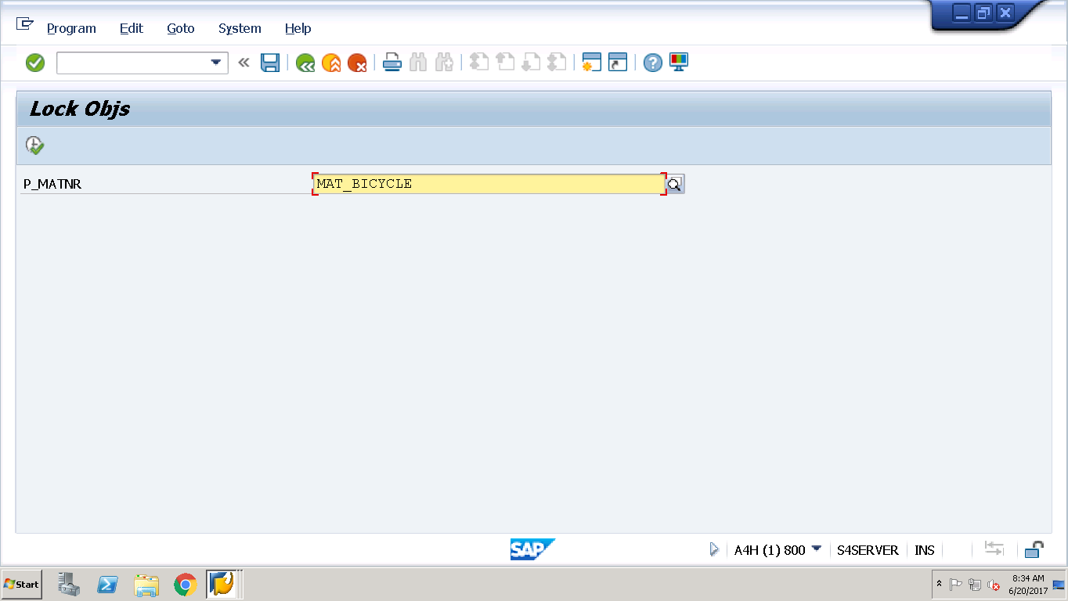

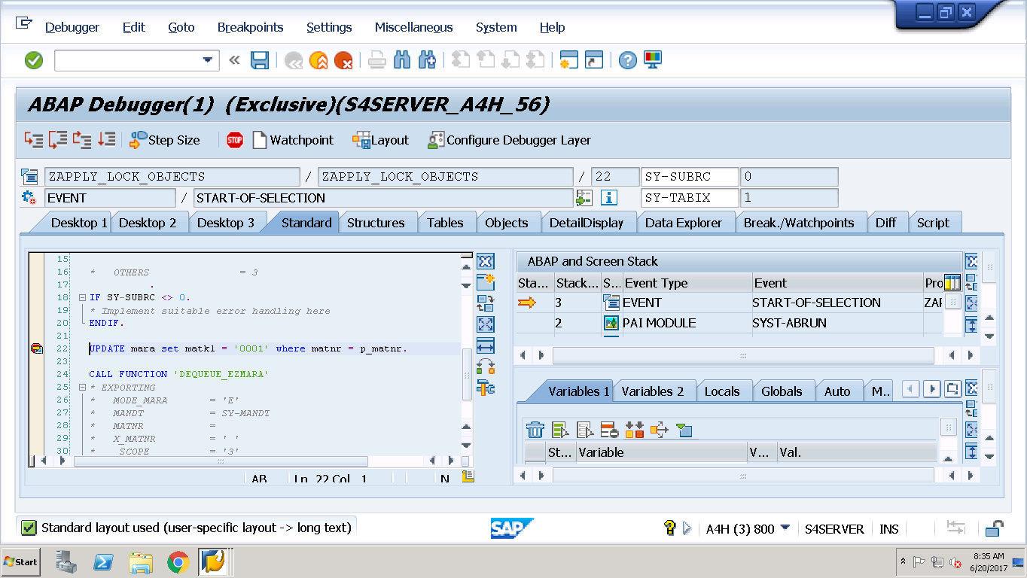

Then open another /omm01 and select the same material.

Now meanwhile, I am trying to change the material via MM02

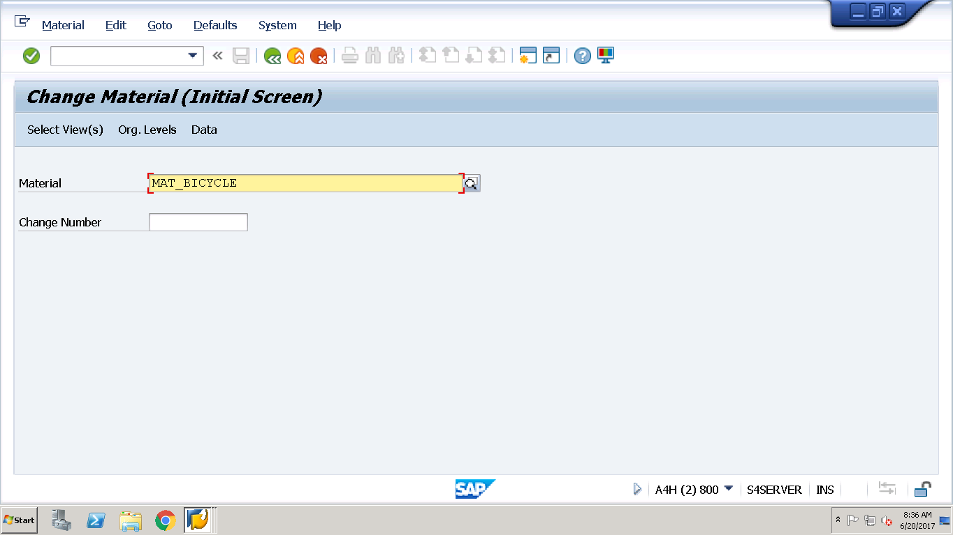

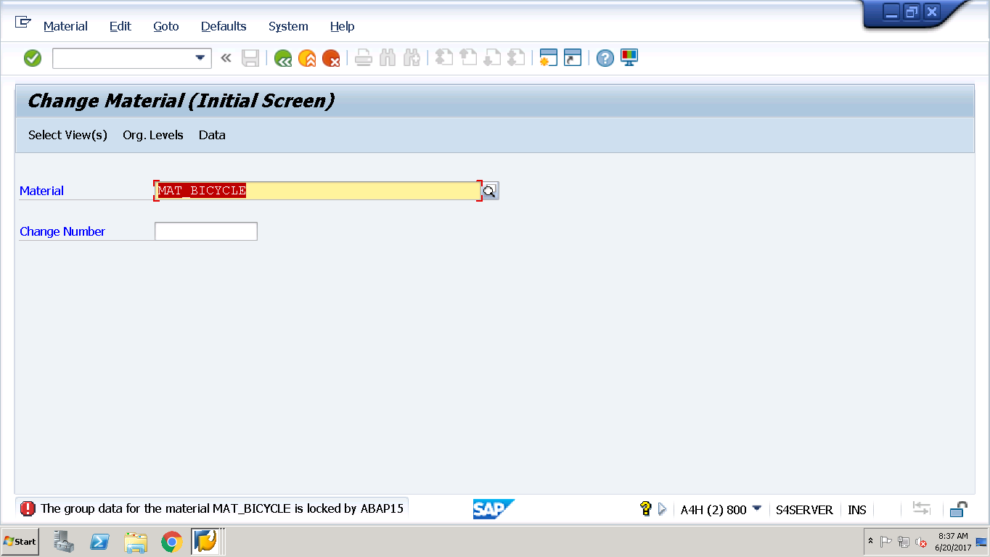

See the Message.